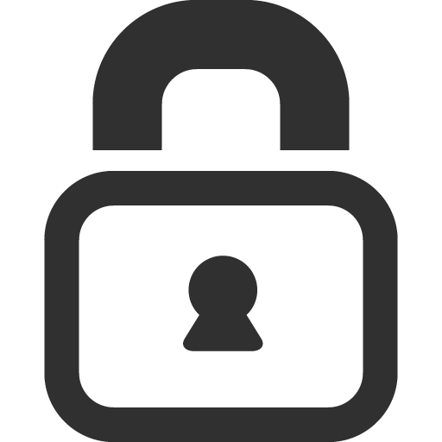

**Islam False**

**Privacy Policy**

What information do we collect?

We **don't** collect any personal and activity data.

# Do we share personal information?

We **don't** share personally identifiable information (such as name, address, email or phone) with other companies as we **don't** collect any.

# Do ad companies collect data?

We currently **don't** provide ads.

# Do we use vendors or analytics providers?

We **don't** use vendors or analytics providers.

# How do we secure personal data?

We **don't** collect any personal data.

# What else should users know?

This privacy policy was last updated on 1/3/15. Our privacy policy may change from time to time. If we make any material changes to our policies, we will place a prominent notice in our application.